# Pset 2

Equation

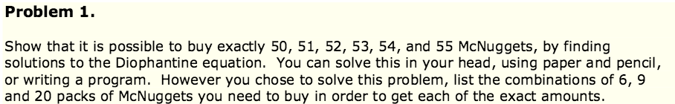



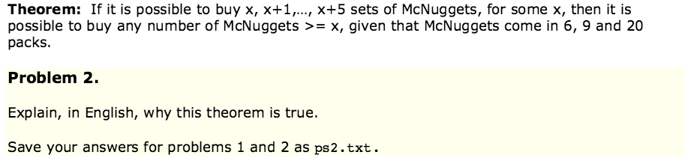

This is because if you can have a number x (like 50) such that you can make x+1,x+2 ect. Then once you reach x+6 you can simply take x and ad done extra 6 piece mcnugget to the same configuration.

6 12 18 24 30 36 42

9 18 27 36 45 54

